MINI QUIZ GAME


TEAM MEMBERS:
25A31A4326 P.Manyatha
25A31A4359 P.Mohith sai murali
25A31A4309 G.Pavani
25A31A4350 L.Adithya
25A31A4317 K.Sri satya sai

MINI QUIZ GAME
Features Required:
- Display quiz instructions to the user
- Display multiple-choice questions with options
- Accept user answer for each question
- Check the correctness of the answer
- Calculate and update score

Concepts to be Used:
- Variables and Data Types
- Arrays
- Loops
- Conditional Statements
- Functions

Technology Used:
C Programming Language

Output:
- Console-based interactive MINI QUIZ GAME
- Displays questions, options, and final scor

Mini Quiz Game
1. Introduction
The Mini Quiz Game is a simple interactive application designed to test the knowledge of users through multiple-choice questions. It allows users to answer questions, receive instant feedback, and view their final score at the end of the quiz. The game is easy to use and helps make learning more interesting and engaging.
This project is mainly developed to understand basic programming concepts such as variables, loops, conditional statements, arrays, and functions. The Mini Quiz Game can be used for educational purposes, practice tests, or entertainment. It provides an effective way to improve logical thinking and problem-solving skills.

2. Objectives
The main objectives of the Mini Quiz Game are:
- To design an interactive quiz application
- To test the knowledge of users in a simple way
- To implement multiple-choice questions
- To calculate and display the user’s score
- To improve logical thinking and programming skills
- To provide instant feedback for correct and incorrect answers

3. System Features
1. User-Friendly Interface
The system provides a simple and easy-to-understand interface that allows users to answer questions without any difficulty.
2. Multiple-Choice Questions
Each question is displayed with four options. The user must choose one correct answer from the given options.
3. Score Calculation
The system automatically calculates the score based on the number of correct answers selected by the user.
4. Instant Feedback
After selecting an option, the system informs the user whether the chosen answer is correct or incorrect.
5. Final Result Display
At the end of the quiz, the system displays the final score along with the total number of questions attempted.
6. Error Handling
The system handles invalid inputs and prompts the user to enter a valid option.
• Real-Time Notifications – Alerts users about important updates or actions.
• Search & Filter Functionality – Helps users quickly find required information.
• Data Storage & Management – Securely stores and organizes system data.
• Scalability – System can handle increased users or data without performance loss.
• Error Handling – Detects errors and provides clear messages to users.
• Backup & Recovery – Protects data with regular backups and recovery options.
• Performance Optimization – Fast response time and efficient processing.
• Audit Logs – Tracks user activities for monitoring and security purposes.
• Cross-Platform Compatibility – Works on different devices and browsers.
• Report Generation – Generates summaries and detailed reports when needed.
• System Maintenance – Easy updates and bug fixes without disrupting users.
• Security Features – Protects against unauthorized access and data breac

4. Workflow of the Mini Quiz Game
- The quiz game starts
- Instructions are displayed to the user
- The first question along with multiple options is shown
- The user selects an answer
- The system checks the selected answer
- The score is updated if the answer is correct
- Steps 3 to 6 are repeated for all questions
- The final score is calculated
- The result is displayed to the user
- The quiz game ends
File Handling Approach for Mini Quiz Game
The Mini Quiz Game uses file handling to store, retrieve, and manage quiz data efficiently. This ensures that data remains available even after the program is closed.
1. Question Storage
- Quiz questions, multiple-choice options, and correct answers are stored in a text file.
- Each question is saved in a structured format for easy reading by the program.
- This allows new questions to be added or modified without changing the source code.
2. File Reading
- When the game starts, the system reads the question file.
- Questions are loaded sequentially or randomly from the file.
- This enables dynamic gameplay with different questions each time.
3. User Score Storage
- Player names and scores are saved in a separate score file.
- After completing the quiz, the player’s result is written to the file.
- This helps maintain a record of past performances.
4. File Writing
- The system uses file writing to store user results after each quiz attempt.
- Data is appended to the file so previous records are not overwritten.
Sample output
------------------------------------
MINI QUIZ GAME
------------------------------------

Enter your name: SATYA

Instructions:
1. Each question carries 1 mark.
2. No negative marking.
3. Choose the correct option (A/B/C/D).

------------------------------------

Q1. What is the capital of INDIA?
A. MUMBAI
B. NEW DELHI
C. KOLKATA
D. CHENNAI

Your answer: B
Correct!

Q2.WHO IS KNOWN AS FATHER OF NATION ?
A. JAWAHARLAL NEHRU
B. SUBASH CHADRA BOSE
C. MAHATMA GANDHI
D. BHAGAT SINGH

Your answer: C
Correct!

Q3. Which PLANET IS KNOWN AS RED PLANET ?
A. EARTH
B. VENUS
C. MARS
D. JUPITER

Your answer: C
Correct!

------------------------------------
Quiz Completed!
------------------------------------

Player Name : SATYA

Total Questions : 3
Correct Answers : 3
Score : 3 / 3

Thank you for playing the Mini Quiz Game!
Conclusion Matter for Mini Quiz Game:
The mini quiz game was designed to test and improve knowledge in a fun and interactive way. It challenged players to think quickly, recall facts, and learn new information. By participating, players not only enjoyed themselves but also enhanced their understanding of the topic.
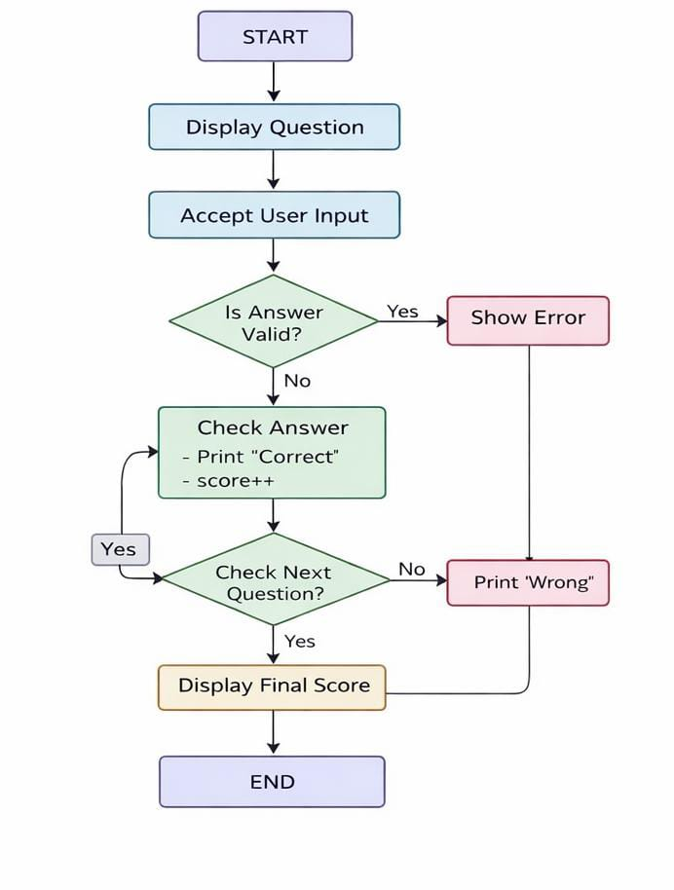
WORK FLOW
